AM Java Internship

ENVIRONMENT INSTALLATION GUIDE

Contents

1 Useful links 3

2 INSTALLING AND CONFIGURING - JAVA JDK 8 4

3 INSTALLING AND CONFIGURING MAVEN 7

4 INSTALLING AND CONFIGURING Tomcat 8

5 INSTALLING AND CONFIGURING Git and git extension 9

6 INSTALLING AND CONFIGURING Postgresql 10

7 INSTALLING AND CONFIGURING IntelliJ IDEA 11

# Useful links

1. <https://one.endava.com/Pages/default.aspx> (use your account credential to log in)
2. <https://eel.endava.com/> (use your account credential to log in)
3. <https://cds.endava.com/> (use your account credential to log in)

# INSTALLING AND CONFIGURING - JAVA JDK 8

1. Download latest JDK 8 version from [link](http://www.oracle.com/technetwork/java/javase/downloads/jdk8-downloads-2133151.html)

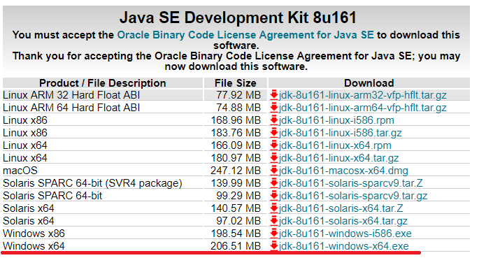

1. Install using default properties

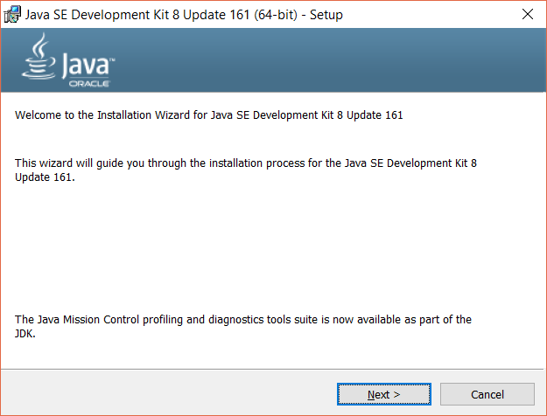 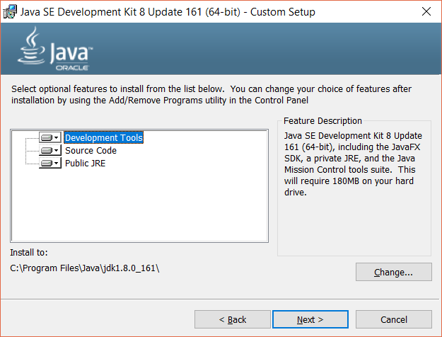

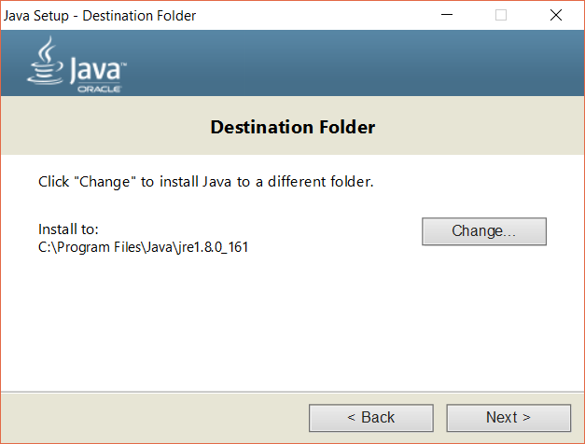 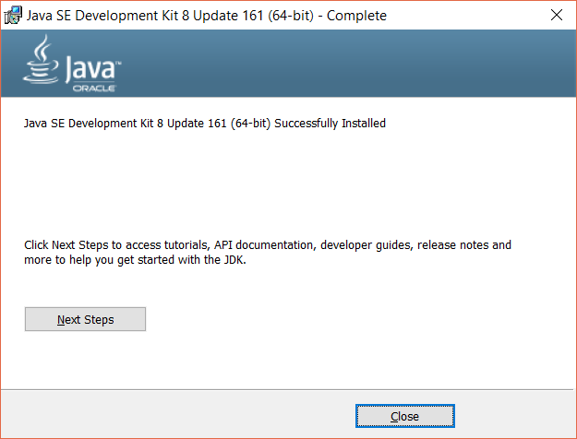

1. After Installation right click on “This PC” ->“Advanced System Properties” -> “**Environment Variables**”

(Or on “Start” icon on “Task Bar” -> “Settings” -> “System Info” -> “Advanced System Properties” -> “**Environment Variables**”)

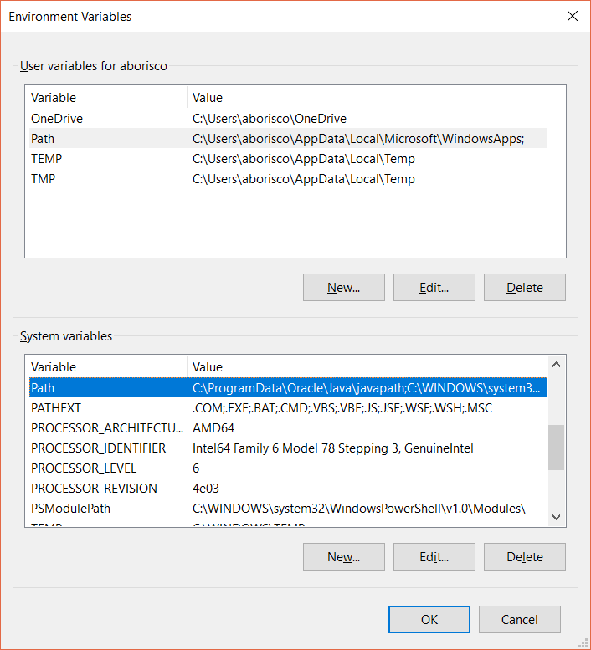

1. On opened window click “New” in System Variables side, and fill columns with next data:

* Variable name - JAVA_HOME
* Variable value - Java root folder\jdk_version ( example C:\Program Files\Java\jdk1.8.0_131)

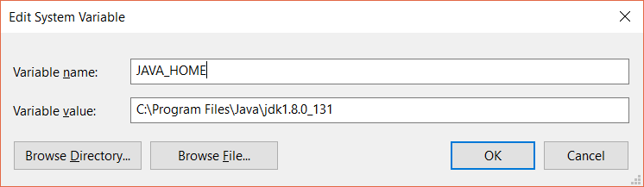

1. After this create another one with next data:

* Variable name - JRE_HOME
* Variable value - Java root folder\jre_version ( example C:\Program Files\Java\jre1.8.0_131)

1. After in System Variables side find “Path” and click edit. In Opened window click “New” and insert next:

* %JAVA_HOME%\bin
* %JRE_HOME%\bin

1. Run “cmd” and write next command: **java -version.** Than you should see next:

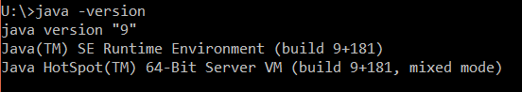

**You also can use the next installation guide** [**video link**](https://www.youtube.com/watch?v=LlLRjFptXAY)

# INSTALLING AND CONFIGURING MAVEN

You can use any maven version

1. Download Maven using the next [link](https://maven.apache.org/download.cgi). You will need to download “**Binary zip archive**” using “**Link**”

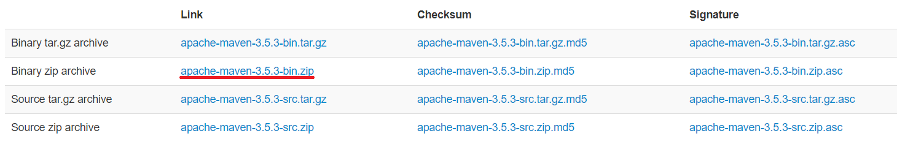

1. After installing create special directory with programs in second disc (example D:\Programs)

**This is required in order to avoid different errors during work. Please also use this directory for Tomcat and PostgreSQL**

1. Create special directory for Maven and unzip downloaded file
2. Open “**Environment Variables**”. Click “New” in System Variables side, and fill columns with next data:

* Variable name - M2_HOME
* Variable value - Maven root folder\maven_version ( example D:\Programs\Maven\apache-maven-3.5.0)

1. After this in System Variables side edit “Path”, And create “New” with next data:

* %M2_HOME%\bin

1. Run “cmd” and write next command: **mvn -version**. Than you should see next:

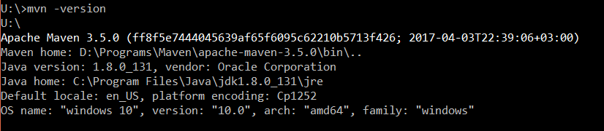

**You also can use next installation** [**video link**](https://www.youtube.com/watch?v=mojFbCzcHIo) **and this** [**link**](https://maven.apache.org/install.html)

# INSTALLING AND CONFIGURING Tomcat

You can use any version of Tomcat, but we strongly recommend to use 8 or 9 version

1. Download latest 8 version from [link](https://tomcat.apache.org/download-80.cgi)

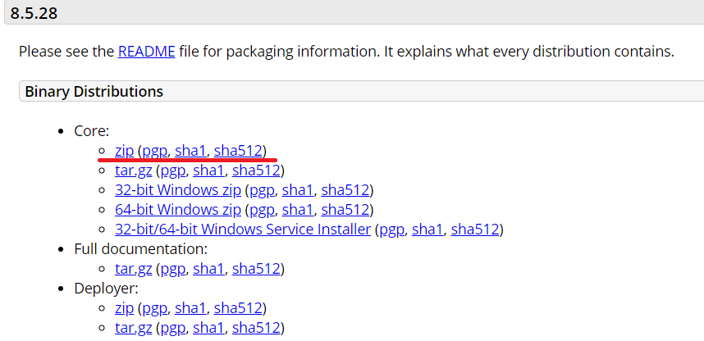

1. As was mentioned before create special directory for Tomcat and unzip downloaded file.
2. Open “**Environment Variables**”. Click “New” in System Variables side, and fill columns with next data:

* Variable name - CATALINA_HOME
* Variable value - Tomcat root folder\tomcat_version ( example D:\Programs\Tomcat\apache-tomcat-8.5.15)

1. After this in System Variables side edit “Path”, And create “New” with next data:

* %CATALINA_HOME%\bin

1. Open Tomcat folder and enter in bin directory (example D:\Programs\Tomcat\apache-tomcat-8.5.15\bin). In this folder run **startup.bat**. After run you should see next:



1. After this go to <http://localhost:8080/>. If page is working, everything is done well, and you can close cmd window and run **shutdown.bat**

**You also can use next installation** [**video link**](https://www.youtube.com/watch?v=pKMgr8uNvGM) **and this** [**link**](https://tomcat.apache.org/tomcat-8.0-doc/setup.html#Windows)

# INSTALLING AND CONFIGURING Git and git extension

You can use any version of Git and Git Extension

1. Download git from next [link](https://git-scm.com/download/win)
2. Install using default profile
3. In order to do starting configuration of the Git open **git-bash** or **cmd.** In opened console write next:

* git config --global user.name "John Doe"
* git config --global user.email johndoe@example.com

**You also can use next installation** [**video link**](https://www.youtube.com/watch?v=PEKN8NtBDQ0&t=316s) **and this** [**link**](https://kuroikaze85.wordpress.com/2009/12/16/git-on-windows/) **or** [**link**](https://git-scm.com/book/ru/v1/%D0%92%D0%B2%D0%B5%D0%B4%D0%B5%D0%BD%D0%B8%D0%B5-%D0%9F%D0%B5%D1%80%D0%B2%D0%BE%D0%BD%D0%B0%D1%87%D0%B0%D0%BB%D1%8C%D0%BD%D0%B0%D1%8F-%D0%BD%D0%B0%D1%81%D1%82%D1%80%D0%BE%D0%B9%D0%BA%D0%B0-Git)

**For quick start in Git we recommend next links:**

* [**http://rogerdudler.github.io/git-guide/**](http://rogerdudler.github.io/git-guide/)
* [**https://githowto.com/ru**](https://githowto.com/ru)
* [**https://proglib.io/p/git-for-half-an-hour/**](https://proglib.io/p/git-for-half-an-hour/)
* [**https://bookflow.ru/kurs-git-bystryj-start/**](https://bookflow.ru/kurs-git-bystryj-start/)
* [**https://www.tutorialspoint.com/git/git_quick_guide.htm**](https://www.tutorialspoint.com/git/git_quick_guide.htm)

**And for more deep understanding next** [**link**](https://git-scm.com/book/ru/v1/%D0%92%D0%B2%D0%B5%D0%B4%D0%B5%D0%BD%D0%B8%D0%B5-%D0%9F%D0%B5%D1%80%D0%B2%D0%BE%D0%BD%D0%B0%D1%87%D0%B0%D0%BB%D1%8C%D0%BD%D0%B0%D1%8F-%D0%BD%D0%B0%D1%81%D1%82%D1%80%D0%BE%D0%B9%D0%BA%D0%B0-Git)

1. We recommend to use Git Extension as a UI for Git, that can be downloaded by next [link](http://gitextensions.github.io/)
2. Download any preferred version and install using default settings.

**All required documentation can be found on next** [**link**](http://git-extensions-documentation.readthedocs.io/en/latest/git_extensions.html)

# INSTALLING AND CONFIGURING Postgresql

For the internship we recommend to use PostgreSQL

1. Download PostgreSQL using next [link](https://www.enterprisedb.com/downloads/postgres-postgresql-downloads). We strongly recommend to use version 9.6
2. Run installation.

Insert and remember the password

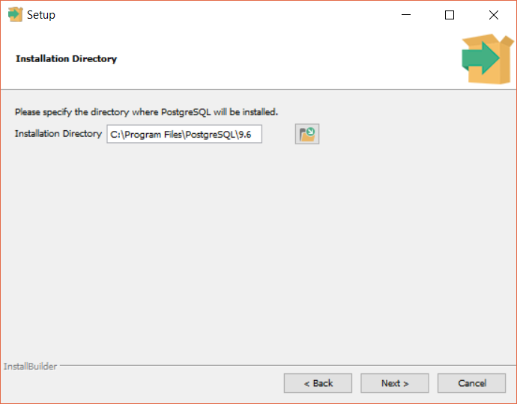 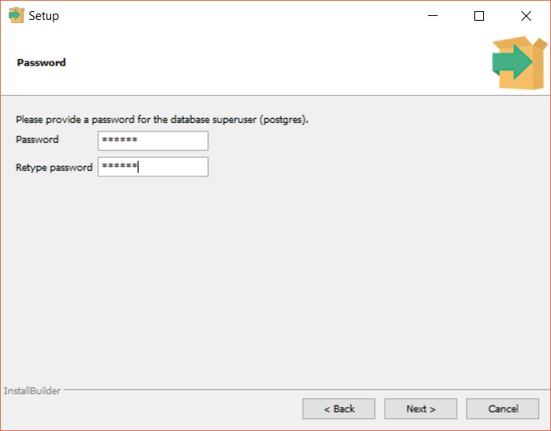

Use default port

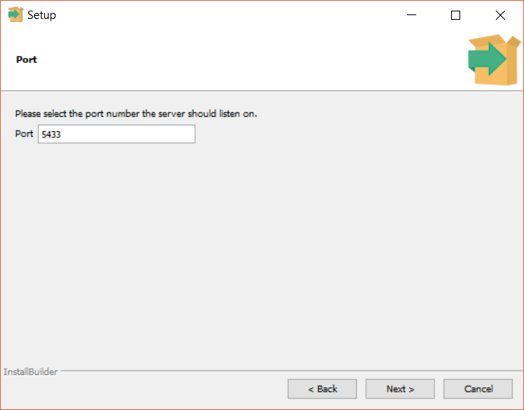 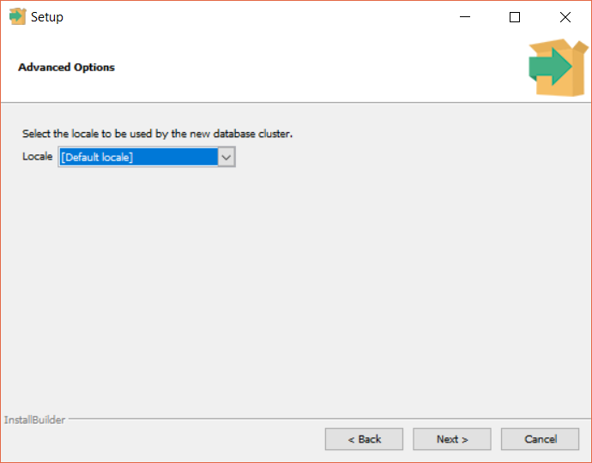

1. After installation you will need UI, so download pgAdmin 4 using next [link](https://www.pgadmin.org/download/pgadmin-4-windows/)

**You also can use next installation** [**video link**](https://www.youtube.com/watch?v=e1MwsT5FJRQ)

# INSTALLING AND CONFIGURING IntelliJ IDEA

During internship program you will use IntelliJ IDEA Ultimate version

1. Download latest ultimate version of IDEA from next [link](https://www.jetbrains.com/idea/download/#section=windows)
2. Install IDEA using default profile
3. After installation run IDEA. You will need to register your version. To do that you need to enter next “License server” in activation window:

**http://jetbrains-license.endava.net:1111/**

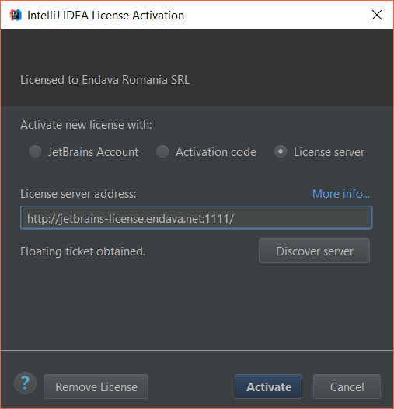

**Important:**

Please don’t share this server link to anyone outside the Endava

After this installation you require to configure IntelliJ IDEA for work.

1. JDK properties

For default IDEA sets last version of JDK for each project, in order to change this default property go to “File”->”Other Settings”->”Default Project Structure..”

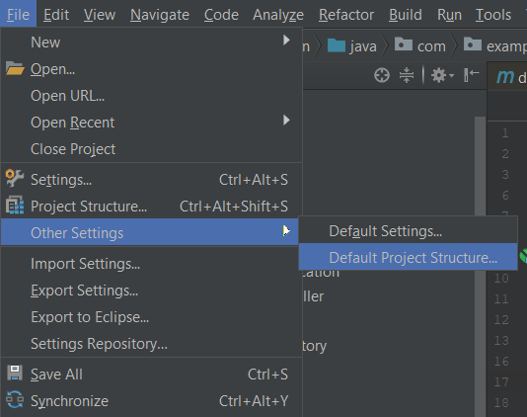

On the opened window click “New” and indicate previously installed JDK

You also can change “Project language level” to 8

1. Maven properties

IDEA also use its own version of Maven, so you will need to change it. Go to “File”-> ”Settings” -> ”Built, Execution, Deployment” -> “Built Tools” -> “Maven”

Change maven home directory to previously installed

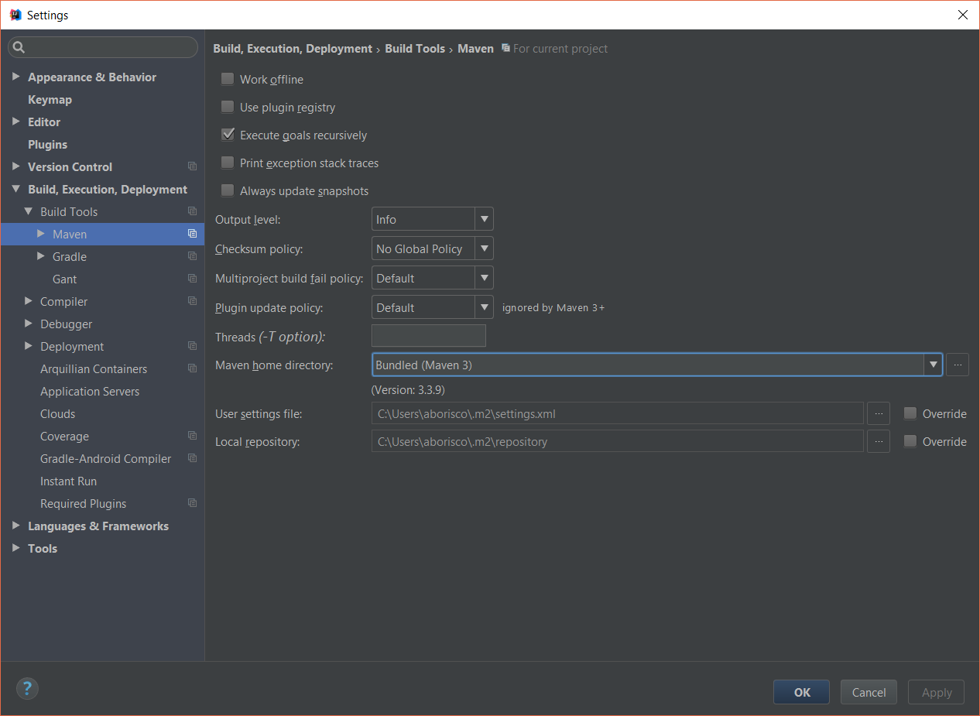

1. Tomcat configurations

When you create your own WEB project or use some examples you will need to run it using Tomcat.

In order to configure it you will need to go “Run”-> ”Edit Configuration”. On opened window click on “Local” as shown at picture:

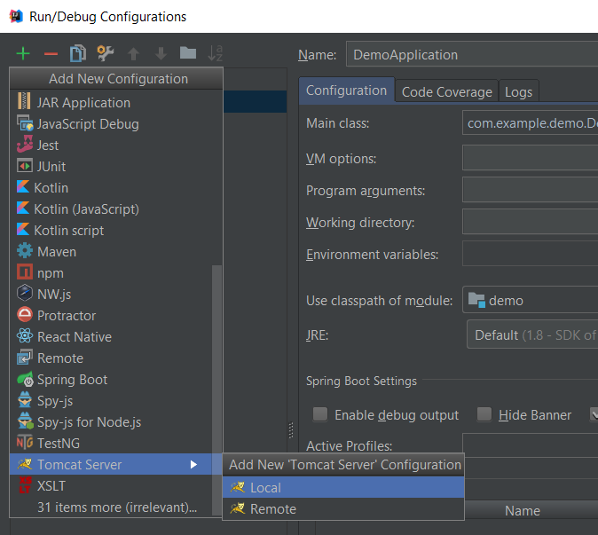

Then click on configure and set directory to previously installed Tomcat

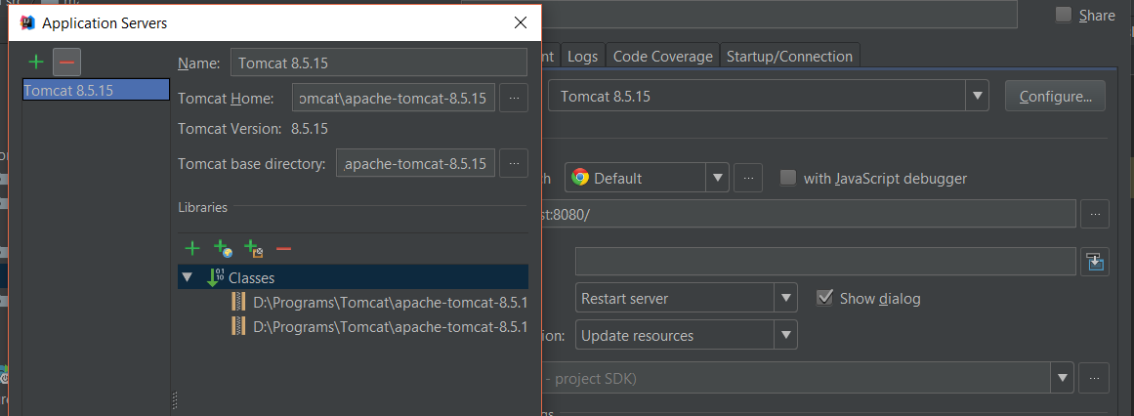

After this you will need just to add artifacts for build and Run application